**Cloud-Based Smart Health Care System**

Ajay Kumar Shrivastava1, Khushi1, Chhayank Tyagi1, Hanu Agarwal1, Harsh Khatter1

1KIET Group of Institutions, Delhi-NCR, Ghaziabad, Uttar Pradesh, India

[ajay@kiet.edu](mailto:ajay@kiet.edu)

[khushi.2024cs1208@kiet.edu](mailto:khushi.2024cs1208@kiet.edu)

[chhayank.2024cs1010@kiet.edu](mailto:chhayank.2024cs1010@kiet.edu)

[hanu.2024cs1020@kiet.edu](mailto:hanu.2024cs1020@kiet.edu)

[harsh.khatter}@kiet.edu](mailto:harsh.khatter%7d@kiet.edu)

**Abstract.** The primary goal of this work is to meticulously analyze the patient’s medical history and the current disease to suggest the appropriate treatment and remedial plan in consultation with the experts. The data is taken as the patients' reports, encompassing details like medical history which is fetched by the system; and identification of suitable physicians based on user-provided symptoms and accompanying reports to get the best support from the proposed solution. A pivotal aspect of this work is the integration of a feature for generic medicines, which aims to augment existing healthcare systems. Whatever the treatment is offered by the doctor, based on the medicine drug, the suggestions of the medicines i.e. normal or generic; are shown to the user with the purchasing options from other websites. This is a smart healthcare solution which uses data analysis, data recommendation and suggestions using information retrieval. Furthermore, machine learning models are applied to match the symptoms of the patients in the existing dataset, and help the doctors to enhance the user experience and ensure personalized care. The multifaceted approach in healthcare outlined in this paper is imperative in the current moment.

**Keywords:** Cloud Computing, Health Care, IoT, Image Processing, Information Retrieval, Recommendation.

**1 Introduction**

In the contemporary landscape of healthcare, significant transformations are being driven by emerging technologies, notably encapsulated in the concept of "smart care." This initiative harnesses cutting-edge advancements such as artificial intelligence (AI), the Internet of Things (IoT), and data analytics to revolutionize patient care, diagnosis, and treatment [1]. These integrated technologies offer unprecedented opportunities to enhance healthcare delivery by enabling real-time patient monitoring, proactive identification of health issues, and the customization of treatment plans tailored to individual needs. The overarching goal of "smart care" extends beyond mere efficiency gains, aiming to democratize access to healthcare services for a broader demographic [2].

Amidst the dynamic landscape of healthcare, there persists an ongoing pursuit of innovative solutions to adapt to evolving patient and provider demands. The "smart care" initiative exemplifies this commitment, leveraging AI, IoT, and data analytics to leverage the latest technological advancements for the betterment of healthcare delivery [3]. These transformative technologies empower healthcare professionals with deeper insights into patient health, expedite decision-making processes, and foster a patient-centric healthcare paradigm [4]. As "smart care" continues to evolve, it underscores the unwavering dedication of healthcare entities to leverage innovation and technology for the betterment of patient care, ushering in a new era of medical excellence [4].

However, the transition to online healthcare is not without its challenges, notably concerning data privacy and security [5][6]. The proliferation of sensitive patient information across digital platforms raises concerns regarding unauthorized access and cyber threats. Moreover, the absence of standardized regulations in online healthcare services contributes to variations in quality and reliability, potentially jeopardizing patient safety. Disparities in access, particularly among marginalized populations, exacerbate existing healthcare inequalities, while issues regarding the accuracy of online diagnoses and medical information interpretation pose additional hurdles to effective virtual healthcare delivery [7]. Addressing these challenges is imperative to establish a robust and inclusive online healthcare ecosystem.

The Smart Care project comprises four primary modules, delineating the core functionalities of the platform [8][9][10]. The Home page serves as the central hub, providing essential information such as the project's vision, mission, and terms of service. The Service page outlines the various offerings, including Blood Bank, E-pharmacy, Path Labs, Gym, Yoga, and Homeopathy services. The Doctor module facilitates seamless interaction for healthcare professionals, enabling them to access patient information, manage appointments, and collaborate with affiliated hospitals. Similarly, the Patient module empowers patients with personalized dashboards to track medical history, consult with doctors, and upload relevant documents, fostering a comprehensive and patient-centric healthcare experience.

**2 Literature Survey**

The literature review offers a comprehensive insight into various aspects of health, encompassing domains such as information systems, workforce administration, and international health regulations. The Kenya Health Workforce Information System (KHWIS) demonstrates improved regulation and policymaking, yet its limited incorporation in government records raises questions about widespread adoption. Aflatoxicosis research reveals the need for a more comprehensive exploration of human health consequences, shifting from predominantly animal-focused studies.

Khatter H. et al. (2022) discussed a model for the data pre-processing of the covid patients, which is shown in Figure 1.

**Fig. 1.** Covid dataset pre-processing model [1]

China's primary healthcare system faces challenges in structural characteristics and human resource management, suggesting the potential for integrated solutions, but issues in workforce education and turnover persist. Human Resource Management (HRM) emerges as crucial for global health care, but a call for refocus and increased research to guide policy development is apparent. Health-system-wide programs, like Patient Blood Management (PBM), exhibit positive outcomes, yet specific drawbacks remain unaddressed. Global health education confronts challenges, emphasizing the significance of partnerships, while mobile health applications demonstrate promise in resource-limited settings, though technology access challenges linger. The survey of the similar works is shown in Table 1. The studies provided offer insights into various aspects of global health systems and challenges. Waters et al. (2013) examine the impact of the Kenya Health Workforce Information System (KHWIS), highlighting its positive effects on health worker regulation and policy, despite limited government references. Williams et al. (2004) focus on aflatoxicosis in developing nations, noting its adverse effects on nutrition and immunity, albeit with limited human health data. Xi and Cheng (2017) discuss challenges in China's primary healthcare system, suggesting opportunities for integration despite workforce qualification issues (2006) stress the critical role of Human Resource Management (HRM) in healthcare globally, advocating for policy focus amid workforce challenges. Leahy et al. (2017) gift a a success health-device-huge Patient Blood Management (PBM) application, yielding price savings and progressed outcomes, with out a specified drawbacks. Ruedy et al. (2014) highlight challenges in worldwide health education and the importance of partnerships, albeit with constrained insights. Salami et al. (2018) discuss the effect of cellular health on maternal care in aid-confined settings, highlighting improved services regardless of capacity technological demanding situations. Danso et al. (2016) show GIS application in hospital location optimization, emphasizing its blessings whilst acknowledging ability data accuracy issues. Graham et al. (2016) endorse for popular health insurance, stressing worldwide action with out particular movement plans. McKee et al. (2014) speak the shift from sovereignty to cohesion in worldwide fitness policy, emphasizing the significance of team spirit but imparting few coverage guidelines. Overall, these studies underline the significance of innovative solutions, policy recognition, and global collaboration in addressing complex healthcare demanding situations worldwide.

**Table 1.** Survey of the present work related to healthcare

|  |  |  |  |  |
| --- | --- | --- | --- | --- |
| **Author[Year]** | **Description** | **Advantage** | **Implementation** | **Drawback** |
| Keith P. Waters et al.[2013] | Impact of Kenya Health Workforce Information System (KHWIS) on policy and management | Improved health worker regulation, management, and policy; increased relicensing | Successful utilization of KHWIS data in policymaking and regulation | Limited references to KHWIS in government records |
| Jonathan H Williams et al.[2004] | Aflatoxicosis in developing countries: toxicology, exposure, health consequences | Aflatoxin exposure impact on nutrition and immunity; potential for interventions | Focus on animal studies; limited information on human health consequences | Lack of comprehensive data on human health impacts of aflatoxin exposure |
| Xi, Li; Cheng, Kar[2017] | The primary healthcare system in China | Challenges in structural characteristics, incentives, & policies; HRM | Opportunities for integrated primary health care system in China | Inadequate education and qualifications of the healthcare workforce |
| Stefane M Kabene et al.[2006] | Importance of HRM in health care: a global context | HRM is critical for high-quality health care; the need for policy | A refocus on HRM is needed; more research for policy development | Challenges in workforce education and turnover |
| Michael F. Leahy et al.[2017] | Improved outcomes and reduced costs with a health-system-wide–wide PBM program | Reduction in blood product utilization; cost savings; improved patient outcomes | Successful implementation of jurisdiction-wide PBM program | Specific drawbacks not mentioned in the provided excerpt |
| John Ruedy et al.[2014] | The challenge of providing global health education: insights from key informants | Challenges in global health education; the importance of partnerships | Importance of partnerships in addressing global health education challenges | Limited insights from the provided excerpt |
| Olawale Salami et al.[2018] | Impact of mobile health on maternal health care service delivery in limited resource | Improved maternal health care services; enhanced data collection | Successful implementation of mobile health in resource-limited settings | Potential challenges in technology access and infrastructure |
| Samuel Danso et al.[2016] | Application of GIS in optimizing the location of health facilities | GIS benefits in health facility location optimization | Successful application of GIS in health facility planning | Possible challenges in data accuracy and system implementation |
| Wendy J Graham et al.[2016] | Universal health coverage: a call for action | Importance of universal health coverage; key action areas | Call for global action to achieve universal health coverage | Limited details on specific action plans |
| Martin McKee et al.[2014] | Global health in foreign policy: from sovereignty to solidarity | Shift from sovereignty to solidarity in global health; & policy | Importance of solidarity in addressing global health challenges | Limited information on specific policy recommendations |

Geographic Information Systems (GIS) offer advantages in optimizing sanatorium locations, acknowledging capability challenges in facts accuracy and device implementation. The name for widely wide-spread fitness coverage underscores worldwide action, but specifics on movement plans are restrained. The shift from sovereignty to unity in global fitness, mentioned in foreign coverage, emphasizes collaborative efforts, yet concrete coverage tips are less specific. In precis, the literature highlights each strengths and gaps in present healthcare paradigms, calling for in addition research to address diagnosed challenges and enhance international health structures' inclusivity and effectiveness.

Gaps Observed. Despite the improvements in scientific technology and healthcare infrastructure, numerous gaps persist in the modern device. One notable quandary lies in the garage and accessibility of patient records. Traditional systems regularly war to keep a continuing repository of stories and statistics, main to ability delays and inefficiencies in affected person care. Moreover, the dearth of a unified platform for collating and organizing various affected person data contributes to a fragmented healthcare experience. Additionally, the technique of figuring out appropriate medical doctors for specific situations remains a venture. Patients frequently face hurdles in navigating the complicated healthcare panorama to discover professionals relevant to their signs and symptoms. This inefficiency can result in not on time diagnosis and treatment, impacting overall health results.

**3. Proposed System**

The proposed gadget ambitions to revolutionize healthcare via introducing a complete technique to affected person statistics garage and doctor choice. One of the one-of-a-kind capabilities of the proposed answer is its capacity to in shape sufferers with appropriate medical doctors primarily based on furnished symptoms. This progressive algorithm considers a multitude of things, inclusive of the severity of symptoms, beyond scientific records, and the knowledge of healthcare providers. This approach minimizes the effort and time patients traditionally invest in locating the right professional, fostering a extra green and centered healthcare shipping. Beyond these center functionalities, the proposed machine seeks to integrate various healthcare facilities into a cohesive platform. This one-prevent answer ambitions to eliminate the need for patients to navigate disparate systems for extraordinary factors in their healthcare e.G. Yoga, fitness center and so forth. The emphasis on a unified approach contributes to a unbroken and interconnected healthcare enjoy. Secondly, the revolutionary physician choice algorithm represents a paradigm shift in how sufferers connect with healthcare carriers. By automating and optimizing this system, the proposed device minimizes delays in diagnosis and treatment, in the end enhancing health effects. The inclusion of a widespread medicine feature provides another layer of accessibility to the proposed system. By empowering sufferers with data on cost-effective options, the gadget promotes monetary inclusivity in healthcare.

While the proposed solution holds tremendous promise, it's far important to renowned ability demanding situations and recall mitigating strategies. One primary problem is facts protection and privateness. As the system centralizes great amounts of sensitive patient facts, strong security features should be in area to guard against unauthorized access and breaches. By integrating numerous healthcare facilities and incorporating a characteristic for generic drugs, the device strives to offer a holistic, one-forestall answer for sufferers.While challenges exist, the potential benefits in terms of improved patient care, streamlined healthcare processes, and enhanced accessibility make this proposed solution a compelling avenue for further exploration and implementation in the evolving landscape of healthcare. The two main modules of the system are patient and doctor.

**Doctor module.** This is the main module including many features:-

• Profile page includes doctor experience and history of previous hospitals and many more.

• Patient records include all the patients of the doctor with medical history all reports, medicines and diseases.

• Doctors include other doctors that are registered and every doctor can see other doctor profiles for their patients and their knowledge. The data flow diagram of the doctor module is shown in Figure 2.

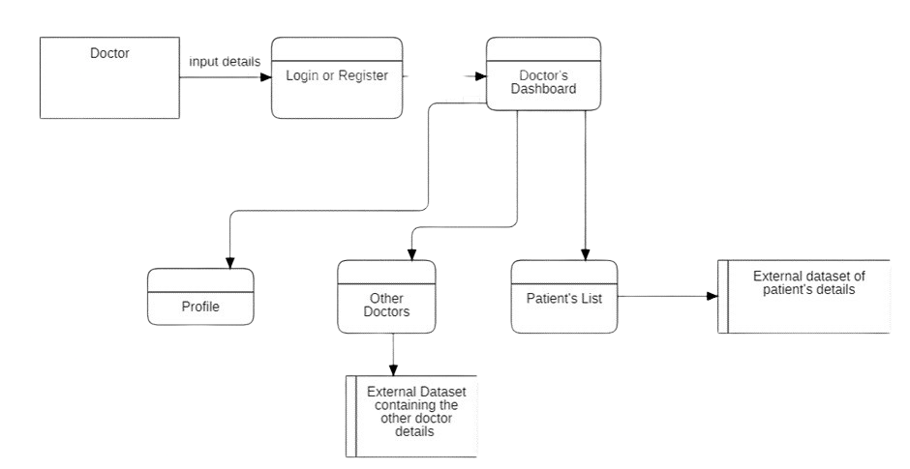

**Fig. 2.** Doctor’s dataflow diagram

**Patient module.** The module includes:-

• Profile page includes patient profiles of previous doctor visits and medical reports.

• All records of various doctors, the visits for checks; and the treatment history with prescriptions given by the doctor.

• Patient can view all their past documents in digital format.The data flow diagram of the patient module is shown in Figure 3.

Another module is the interface where a Service Page is provided for ease of use.

• This is the most important module including many government services and generic services.

• Blood Bank is very necessary nowadays and this module includes access links to government blood bank websites and listing necessary details regarding them.

• E-pharmacy is a service to buy medicines online and deliver them to our doorstep at the lowest price and with an assured company.

• Path Labs is the nearest path lab to your location with price tags of many important medical tests and reports at your doorstep.

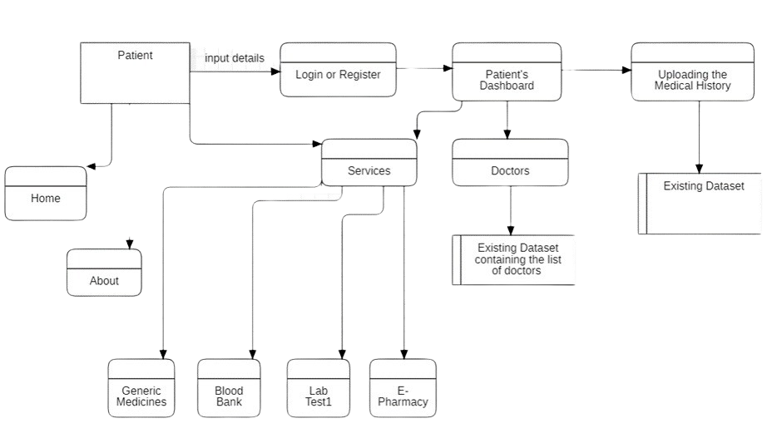

**Fig. 3.** Patient’s dataflow diagram

**3.1 Advantages of the Proposed Work**

* Access **-** access to our website is not restricted to registered users only. Someone who is not registered can also visit the website.
* User Registration and Login **-** A user, must be able to register their credentials. One should provide their basic information e.g. Name, address, email, and phone number to create the profile.
* Electronic Health Records **-** This is a feature to digitalize the patient’s medical records, it’ll contain the patient's medical history, diagnoses, medications, treatment plans, immunization dates, and laboratory test results.
* Telemedicine **-** This feature allows the patient to buy the medicine online from the registered government websites. This feature helps the user to buy the medicines at low prices as compared to all other private medicines shops.
* Online Blood Bank **-** This feature allows the patient to see the blood donor’s availability according to the blood group. This is also the registered and approved government website which will provide the filtered data so that the relevant information of the acceptor and donor is displayed.
* Online Path Labs **-** This feature allows the patient to access the government's official website for appointing the test in pathology labs. This is also the home service provided by the government to the patients.

**4 Implementation**

**4.1 Doctor’s Module**

Doctor’s Dashboard allows doctors to access the appointed patients only. The doctor can see their records also such as medical records, test results and past prescriptions (from another doctor). The doctor has to provide electronic prescriptions, which reduces the risk of errors and makes it easier for patients to refill their prescriptions. It also consists of many other options such as other doctors where the list of registered doctors is made visible; as shown in Figures 4, 5 and 6.

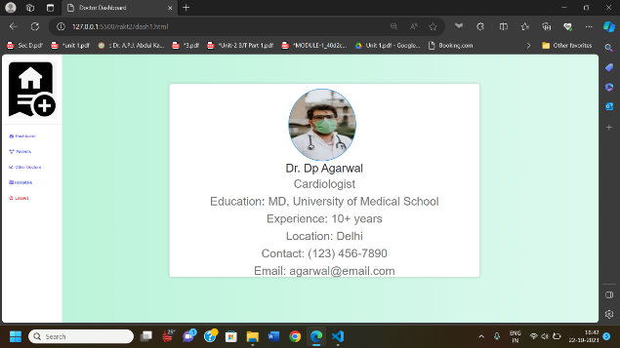

**Fig. 4.** Doctor Profile at the interface

**Fig. 5.** Interface layout for the list of doctors

**Fig. 6.** Patient’s data on the interface

**4.2 Technology Used for the Implementation**

**Hardware.** Even though this architecture is hardware-software integrated web architecture, we will not be designing any specific hardware interfaces to run the system. Our system is a web-based system, so we will be launching it on several computers online. Smart care projects may integrate with EHR systems to provide healthcare professionals with access to patient data. These systems can be connected to the web-based platform via APIs.

**Software.** The Smart Care WebApp will depend on several open-source software components, including HTML, CSS, JavaScript, APIs, Spring MVC, Spring Security, Spring JDBC and Spring Boot. These components will be integrated into the web application to provide the necessary functionality and user interface Once the files have been worked upon, SPS sends a copy of the final PDF of each paper to its contact author. The contact author is asked to check through the final PDF to make sure that no errors have crept in during the transfer or preparation of the files. This should not be seen as an opportunity to update or copyedit the paper, which is not possible due to time constraints. Only errors introduced during the preparation of the files will be corrected. Particular attention should be paid to the references section.

**4.3 Limitations and Scope**

The objective of the work is to meet the requirement goals of the patients and help the social community. The modules discussed like patient, medicine, doctor, etc are helpful for the end-users and provide ease of handling and maintenance. Though, some of the methods and algorithms adopted in the work, can be replaced further by the ensuing algorithms to make the system optimised and more robust. The features can be incorporated into the work to provide a one-roof solution given the existing challenges in the healthcare sector.

**5 Conclusion**

The Smart Healthcare website aims to solve many problems of patients and doctors and it provides the facility of saving medical reports online. Sometimes when patients change their doctors, then some patients lose their prescriptions and are unable to tell doctors about their previous health issues so they can save all of their reports and documents on the platform for a better cure and this helps a lot of patients as well as doctors. The proposed platform is user friendly and is also helpful for the doctor as they can efficiently save all their patient's history. Doctors can also refer prescriptions of other doctors for betterment, both patients and doctors can also compare the price of medicine so that they can save their money.

**References**

1. Amit Kumar Gupta, Ruchi Rani Garg, Arti Sharma, Saurabh and Harsh Khatter, “Mental health analysis on Twitter data”, Presented in 3rd International Conference on Smart Computing and Cyber Security SMARTCYBER, 28-29 June 2023, Kyungdong University, South Korea
2. D. J. Cook, A. S. Crandall, B. L. Thomas, and N. C. Krishnan, "CASAS: A Smart Home in a Box," Computer, vol. 46, no. 7, pp. 62–69, 2013, doi: 10.1109/MC.2012.328.
3. F. Serpush, M. B. Menhaj, B. Masoumi, and B. Karasfi, "Wearable Sensor-Based Human Activity Recognition in the Smart Healthcare System," Computational Intelligence and Neuroscience, vol. 2022, Article ID 1391906, 2022, doi: 10.1155/2022/1391906.
4. H. Khatter, A. Yadav and A. Srivastava, "Machine Learning-Based Automated Medical Diagnosis for Healthcare," 2023 6th International Conference on Information Systems and Computer Networks (ISCON), Mathura, India, 2023, pp. 1-5, Doi: 10.1109/ISCON57294.2023.10112144
5. S. Hitharth, G. B. Mohammad, and K. Sangeetha, "The Fusion of Internet of Things, Artificial Intelligence, and Cloud Computing in Health Care," in Predicting epidemic outbreaks using IoT, artificial intelligence and cloud, Berlin, Germany: Springer, 2021, pp. 197–222.
6. C. Luca, D. D. Donno, L. Mainetti, et al., "An IoT-aware architecture for smart healthcare systems," IEEE Internet of Things Journal, vol. 2, no. 6, pp. 515–526, 2015.
7. E. Sezgin, S. Özkan-Yildirim, and S. Yildirim, “Investigation of physicians’ awareness and use of health apps: a mixed method study,” Health Policy & Technology, vol. 17, no. 4, pp. 133–142, 2017.
8. Agha, L. (2015), “The effects of health information technology on the costs and quality of medical care”, Journal of Health Economics, Vol. 34, pp. 19-30
9. Anagnostopoulos, I., Zeadally, S. and Exposito, E. (2016), “Handling big data: research challenges and future directions”, Journal of Supercomputing, Vol. 72 No. 4, pp. 1494-1516.
10. BroadbandCommission (2017), “Digital health: a call for government leadership and cooperation between ICT and health”, available at: www.broadbandcommission.org/Documents/publications/WorkingGroupHealthReport-2017.pdf (accessed August 2019).
11. Cisco (2019), “Making connected health a reality”, Cisco Systems, available at: www.cisco.com/c/dam/en_us/solutions/industries/docs/healthcare/connected_health_brochure.pdf (accessed August 2019).
12. Grood, C., Raissi, A., Kwon, Y. and Santana, M.J. (2016), “Adoption of e-health technology by physicians: a scoping review”, Journal of Multi-Disciplinary Health, Vol. 9, p. 335
13. Haluza, D. and Jungwirth, D. (2014), “ICT and the future of healthcare: aspects of doctor-patient communication”, International Journal of Technology Assessment in Health Care, Vol. 30 No. 3.
14. Hipaa (2019), “Health information privacy”, available at: www.hhs.gov/hipaa/index.html (accessed August 2019).
15. IHS (2015), “The connected patient”, available at: https://cdn.ihs.com/www/pdf/Technology-White-Paper-The-Connected-Patient.pdf (accessed August 2019).
16. iScoop (2018), “Healthcare in digital transformation: digital and connected healthcare”, available at: www.i-scoop.eu/digital-transformation/healthcare-industry/ (accessed August 2019).
17. Harsh Khatter, Amit Kumar Gupta, Ruchi Rani Garg, and Mangal Sain. 2022. "Analysis of the S-ANFIS Algorithm for the Detection of Blood Infections Using Hybrid Computing" Electronics 11, no. 22: 3733, 14 Nov 2022, https://doi.org/10.3390/electronics11223733
18. Nambiar, A.R., Reddy, N. and Dutta, D. (2017), “Connected health: opportunities and challenges”, IEEE International Conference on Big Data, IEEE, Boston, MA, pp. 1658-1662.
19. Gunjan Raghav, Harsh Khatter, "Intelligent Curation Fuzzy Inference System for Blood Infections in Android”, IEEE 4th International Conference on Computational Intelligence & Communication Technology (CICT), 2018, Ghaziabad, India
20. OCF-Security (2019), “Cloud security specification”, available at: https://openconnectivity.org/draftspecs/Essen/CR%202871%20-%20OCF_Cloud_Security_Specification.pdf (accessed August 2019).
21. Sharma, Sarang; Gupta, Sheifali; Gupta, Deepali; Juneja, Abhinav; Khatter, Harsh; Malik, Sapna; Bitsue, Zelalem Kiros “Deep Learning Model for Automatic Classification and Prediction of Brain Tumor”, Journal of Sensors (2022), Hindawi, Vol 2022(3065656), 8 April 2022. https://doi.org/10.1155/2022/3065656
22. Sethi, M., Arkko, J. and Back, H.M. (2018), “Practical considerations and implementation experiences in securing smart object networks”, IETF RFC, available at: https://tools.ietf.org/html/rfc8387 (accessed August 2019).
23. Williams, P.A. and McCauley, V. (2016), “Always connected: the security challenges of the healthcare internet of things”, 3rd IEEE World Forum on the Internet of Things, Reston, VA.